Dag og tid | Aktivitet | Instruktør | Sted
Mandag
05.30-22.00 | Motionscenter |  | Hal 2 / motionsrum
16.45-18.00 | MBL | Anita Olsson | Hal 2 / lille hal
17.00-18.00 | Body Bike | Morten Mehl | Hal 2/Body Bike.
17.00-18.00 | Løb | Kontor@ffkcentret.dk | P-Pladsen
18.00-20.30 | Motionsbadminton | Kontor@ffkcentret.dk | Hal 1
18.45-19.45 | Body Bike | Bo Pedersen | Hal 2 / Body bike
19.00-22.00 | Præmiewhist | Tage Pedersen | Cafeteriet
19.30-20.30 | Cross Fitness | Morten Olsen | Hal 2/lille hal
Tirsdag
05.30-22.00 | Motionscenter |  | Hal 2 / motionsrum
17.00-18.00 | Yoga | Petra Skovholm | Lille dansesal
17.00-18.00 | Body Bike | Henrik Holmberg | Hal 2 / Body Bike
17.00 -20.30 | Motionsbadminton | Starter i uge 36 | Hal 1
Onsdag
05.30-22.00 | Motionscenter |  | Hal 2 / motionsrum
09.00-10.00 | Body Bike | Marianne Schmidt | Hal 2 / Body bike
16.30-18.00 | Klatring(familie) | Jannik Grumstrup (Starter i oktober) | Hal 1/ Klatrevæg
16.45-18.00 | MBL | Anita Olsson | Hal 2 / lille hal
17.00-18.00 | Body Bike | Henrik Holmberg/Morten Mehl | Hal 2/Body Bike
17.00 -19.00 | Løb | kontor@ffkcentret.dk | P-Pladsen
18.15 – 19.15 | Body Bike | Hanne Mølgaard (NYT HOLD) | Hal 2/Body Bike
20.00-21.00 | Body Bike | Thomas Dalby | Hal2/Body Bike
20.00-21.00 | Motionsbadminton | kontor@ffkcentret.dk | Hal 1
18.00-19.15 | Body Fit | Helle Johansen | Hal 2
19.30-20.30 | Cross Fitness | Morten Olsen | Hal 2/lille hal
Torsdag
05.30-22.00 | Motionscenter |  | Hal 2 / motionsrum
16.30-18.00 | Skumtennis | Finn Ligaard | Hal 1
17.00-18.00 | Body Bike | Bo Pedersen | Hal 2/Body Bike
19.30-20.30 | Body Bike | Mads Bastian | Hal 2 / Body bike
19.30-21.00 | Motionsbadminton | kontor@ffkcentret.dk | Hal 1
Fredag
05.30-20.00 | Motionscenter |  | Hal 2 / motionsrum
16.00-17.00 | Body Bike (BEMÆRK I HOLDET KØRE I LIGE UGER) | Hanne Mølgaard | Hal 2/Body Bike
Lørdag
05.30-20.00 | Motionscenter |  | Hal 2 / motionsrum
Søndag
05.30-20.00 | Motionscenter |  | Hal 2 / motionsrum
09.00-10.15 | Body Bike | Bjarne Pedersen | Hal 2/Body Bike
16.00-17.15 | Body Fit | Helle Johansen | Hal 2/lille hal
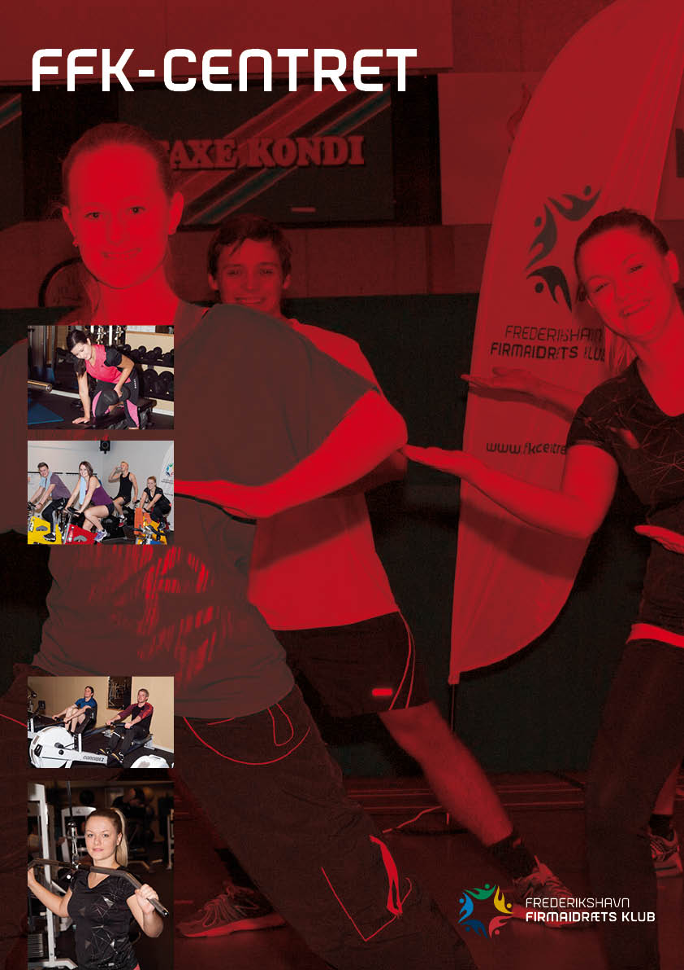

Sæson 2018/19
3. september
Husk vores cykelsimulator
kan du bruge hver dag i centrets åbningstid!
- Ring på tlf. 98 42 70 63
og få oplysninger om pris og bane nr.
Skal du holde en anderledes familiefest, så kan vi godt hjælpe med lokalerne og i lejen har du stor idrætshal med med masser af aktiviteter.
Yderligere oplysninger på vores hjemmeside eller
tlf. 98 42 70 63
Klatre arrangement for klassen
eller venner/veninderne?
Lej en klatreinstruktør.
Ring og hør nærmere.
- ring på 98 42 70 63 og få yderligere oplysninger om pris og bane nr.

