Dag og tid | Aktivitet | Instruktør | Sted
Mandag
05.30-22.00 | Motionscenter |  | Hal 2 / motionsrum
16.45-18.00 | MBL | Anita Olsson | Hal 2 / lille hal
17.00-18.00 | Body Bike | Thomas Dalby | Hal 2/Body Bike.
17.00-18.00 | Løb | Kontor@ffkcentret.dk | P-Pladsen
18.45-19.45 | Body Bike | Bo Pedersen | Hal 2 / Body bike
19.00-22.00 | Præmiewhist | Tage Pedersen | Cafeteria
19.30-20.30 | Cross Fitness |  | Hal 2/lille hal
Tirsdag
05.30-22.00 | Motionscenter |  | Hal 2 / motionsrum
17.00-18.00 | Yoga | Petra Skovholm | Lille dansesal
17.00-18.00 | Body Bike | Henrik Holmberg | Hal 2 / Body Bike
17.00 -20.30 | Motionsbadminton |  | Hal 1
Onsdag
05.30-22.00 | Motionscenter |  | Hal 2 / motionsrum
18.30-19.30 | Klatring(familie) | Thorbjørn Stenholm | Hal 1/ Klatrevæg
16.45-18.00 | MBL | Anita Olsson | Hal 2 / lille hal
17.00-18.00 | Body Bike | Hanne Mølgaard | Hal 2/Body Bike
17.00 -19.00 | Løb | kontor@ffkcentret.dk | P-Pladsen
20.00-21.00 | Motionsbadminton | kontor@ffkcentret.dk | Hal 1
18.00-19.15 | Body Fit | Helle Sørensen | Hal 2
19.30-20.30 | Cross Fitness |  | Hal 2/lille hal
Torsdag
05.30-22.00 | Motionscenter |  | Hal 2 / motionsrum
17.00-18.00 | Body Bike | Bo Pedersen | Hal 2/Body Bike
16.30-17.30 | ZUMBA NYT (start uge 43) | Hejdi Larsen | Hal 2
19.00-20.00 | Body Bike | Henrik Holmberg | Hal 2/Body Bike
19.30-21.00 | Motionsbadminton | kontor@ffkcentret.dk | Hal 1
Fredag
05.30-20.00 | Motionscenter |  | Hal 2 / motionsrum
16.00-17.00 | Body Bike (HOLDET KØRE I LIGE UGER) | Hanne Mølgaard | Hal 2/Body Bike
Lørdag
05.30-20.00 | Motionscenter |  | Hal 2 / motionsrum
Søndag
05.30-20.00 | Motionscenter |  | Hal 2 / motionsrum
09.00-10.15 | Body Bike | Bjarne Pedersen | Hal 2/Body Bike
16.00-17.15 | Body Fit | Helle Sørensen | Hal 2/lille hal
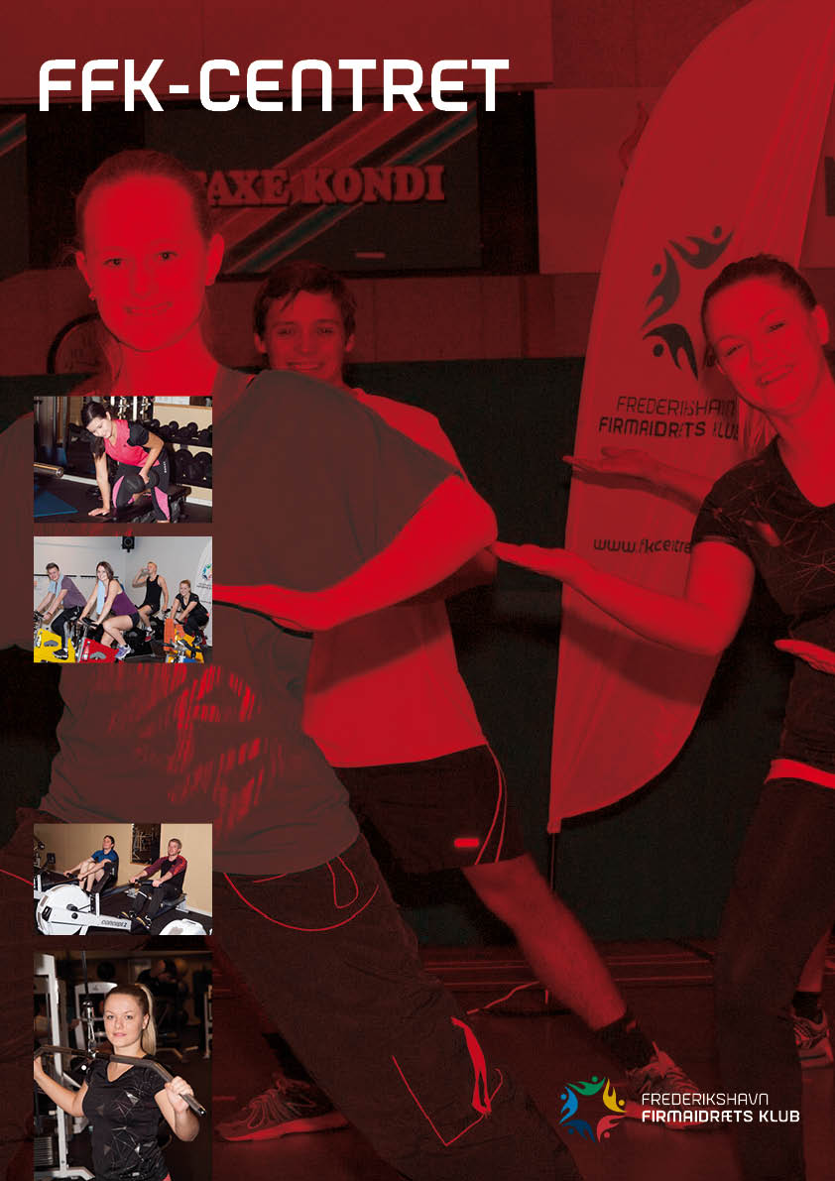

Sæson 2020/21
2. september
Yderligere oplysninger på vores hjemmeside www.ffkcentret.dk eller
tlf. 98 42 70 63
Skal du holde en anderledes familiefest, så kan vi godt hjælpe med lokalerne og i lejen har du stor idrætshal med med masser af aktiviteter.

- Ring på tlf. 98 42 70 63
og få oplysninger om pris og bane nr.
- ring på 98 42 70 63 og få yderligere oplysninger om pris og bane nr.

